Catholic Tipping Point Tour with Marie Collins
“A Crisis of Culture: Seeking Justice to Reclaim the Church”
Washington, DC - Baltimore - Philadelphia - Chicago - New Orleans - Los Angeles
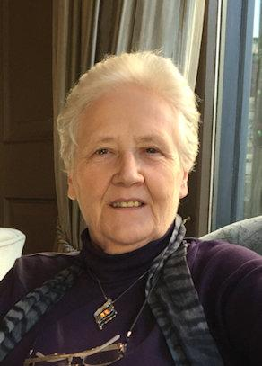
Born in Dublin, Ireland, Marie Collins is a tireless campaigner for the protection of children, for the accountability of the church, and for justice for survivors of sexual abuse, as she herself was a victim of clergy abuse as a 13-year-old. She is a founding trustee of the Marie Collins Foundation and the support group for abuse survivors, One in Four (Ireland), as well as a founding member of the Irish depression support group Aware. She resigned from the Pontifical Commission for the Protection of Minors in 2017.

Tuesday, September 17 from 6:30 – 8 pm
Community Church Unitarian Universalist of New Orleans
6690 Fleur de Lis Dr., NOLA 70124
Jennifer Molina (504) 914-1610

Hosted by New Orleans chapters of: Call to Action, Survivors Network of those Abused by Priests, and Women’s Ordination Conference.

“Survivors will not be satisfied with more words or promises, they need to see real change.” - Marie Collins
www.catholictippingpoint.org

