Catholic Tipping Point Tour with Marie Collins
“A Crisis of Culture: Seeking Justice to Reclaim the Church”
Washington, DC - Baltimore - Philadelphia - Chicago - New Orleans - Los Angeles
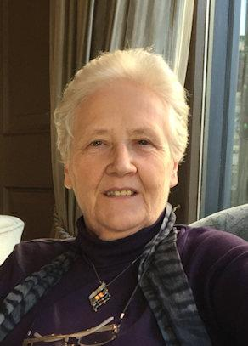
Born in Dublin, Ireland, Marie Collins is a tireless campaigner for the protection of children, for the accountability of the church, and for justice for survivors of sexual abuse, as she herself was a victim of clergy abuse as a 13-year-old. She is a founding trustee of the Marie Collins Foundation and the support group for abuse survivors, One in Four (Ireland), as well as a founding member of the Irish depression support group Aware. She resigned from the Pontifical Commission for the Protection of Minors in 2017.

Saturday, September 14 at 7 pm
First United Church of Oak Park
848 Lake Street, Oak Park, IL 60301

Hosted by Women’s Ordination Conference, Future Church,
Call To Action, Catholics for Choice, Quixote Center, Survivor’s Network for Those Abused by Priests, DignityUSA

“Survivors will not be satisfied with more words or promises, they need to see real change.” - Marie Collins

www.catholictippingpoint.org

